CURRICULOG: HOW TO START A PROGRAM CREATION PROPOSAL (Two Versions)

Curriculog Link: https://samford.curriculog.com
- Click on Login (upper right corner).
- Use your usual Samford login (username and password). (This uses the CAS authentication process.)
- Any Samford faculty/staff member is allowed to access the Curriculog system.

Initial View

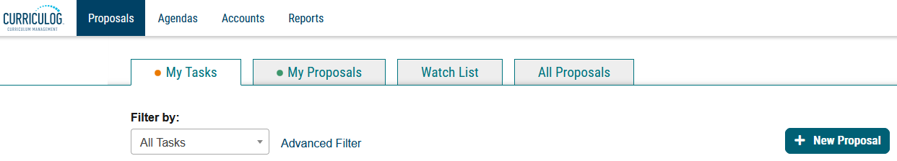

- Click on New Proposal.

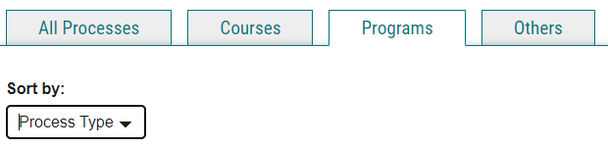

- Click on Programs and Sort by Process Title (or Process Type). (Both sorting processes get you the same results—all the Program Proposals—but the Title vs Type just places them in a different order)
- While there are single proposals for Program Deletion and Program Revision (Undergrad & Grad), there are now two versions for Program Creation.
- The proposals with (Traditional) in the title are the default version and are best for a completely NEW program that has all or mostly all new courses. It does not require you to search on an existing program (because it doesn’t have the import/legend feature). You will jump straight into a blank proposal, ready for you to add data and attach files.
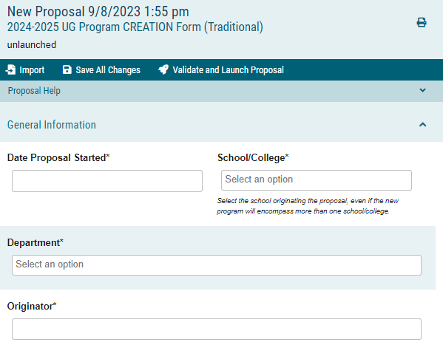

- The proposals with (Special-With Import) in the title are new and are best for new programs that are a variation on an existing program with which it might share a lot of the same courses. It is NOT to be used when an existing program is undergoing a name change and/or program overhaul. (Use the Program Revision form for that).
- When you choose the Special-With Import version, you’ll be prompted to Search Curriculum Inventory:

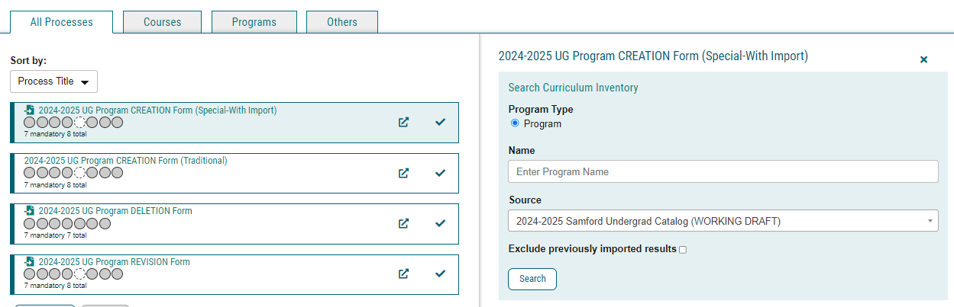

- At this stage, use whatever descriptive terms are needed for your search. If you use a partial word, use an asterisk with it. For example: You can search on “English” or “History” and get several results. If you search on “Soci” you’ll get nothing. But try “Soci*” and you’ll get programs with Social or Sociology in the title.
- Example: Say you want to create a new concentration for the English major. There are already Creative Writing and Film Studies concentrations, but you want a new one for Technical Writing. You would use this new form especially if the overall structure of the major is the same, but only the concentration is unique.

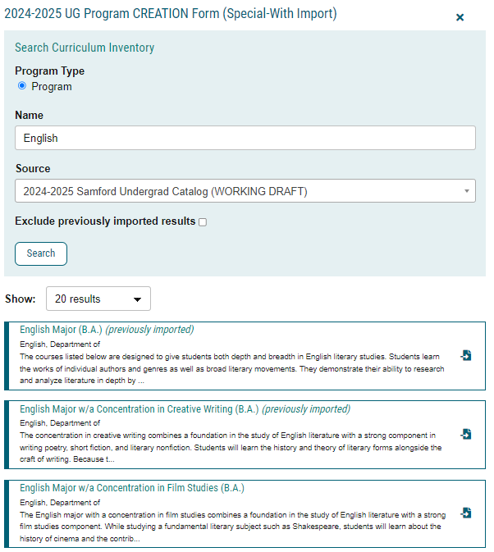

- Choose one of the options and click on the icon on the right:
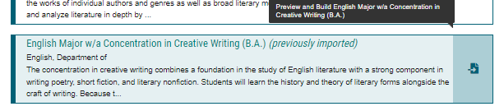

- You will get a summary page.

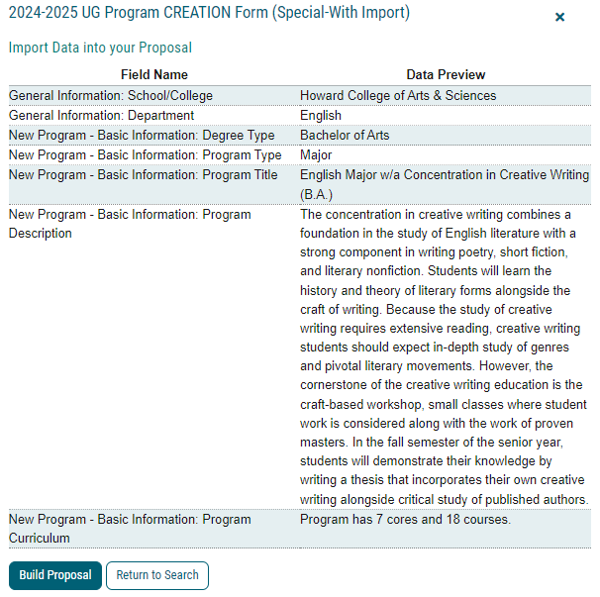

- If that’s the one you want to use as your “template” click Build Proposal.
- You will notice that the School/College and Department names have now been auto populated. (That’s because of the import/legend feature of this version.)

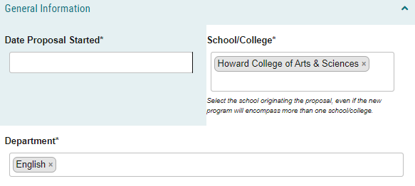

- One of the first things to do is rename the program.

Before
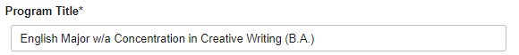
After
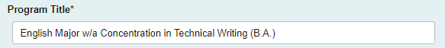

- Click Save All Changes. This ensures that your proposal already reflects the new program name. Now you can proceed to make adjustments to the proposal and answer all required questions.
- It is assumed that the Degree Type and Program Type will remain the same, but…it’s possible you might be creating a BS version of an existing BA program, for example. Adjust the auto populated fields as necessary.
- Revise, add, or remove the existing Program Description.
- Under Program Curriculum you can now make adjustments.
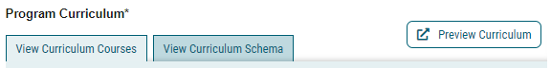
- View Curriculum Courses is the “bucket” of courses currently used in your program while View Curriculum Schema is the table structure as seen in the catalog using those courses.
- IMPORTANT TIP: The Preview Curriculum button provides a view of the program that matches that seen in the catalog. It may be helpful to open that pop-up window and keep it on your screen as you make changes. If you click Save All Changes again, each time you click on Preview Curriculum you will get a new pop-up window reflecting those changes.
- Because this proposal version has the import feature, you can use the Import Course button at the bottom of the first page to add more options to the “bucket” of courses in the program.
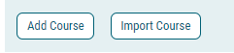
- Click Import Course. A new pop-up window will appear.
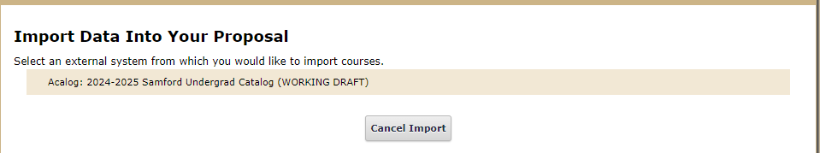
- Hover over the far right and you’ll see a blue check mark appear.
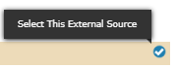
- Click anywhere in that tan/beige bar to select.

- Click in the “Or add filter” box and select Prefix from the drop-down list.

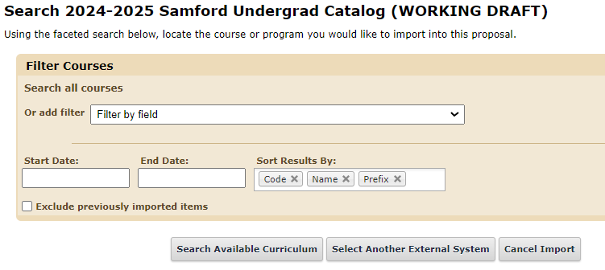
- Enter a prefix (such as COMS) and Click Search Available Curriculum to get a list of course options.
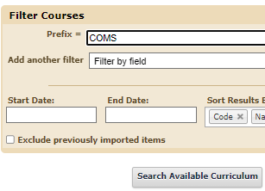
- Select the desired courses.

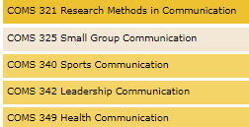

- Those courses will now appear at the bottom of that window.
- Click Add Courses to Proposal
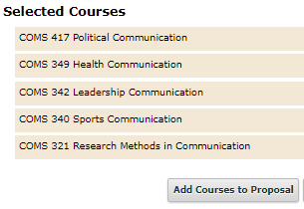
- And voila, those courses will now appear in the “bucket”—complete with number, title, and credits.
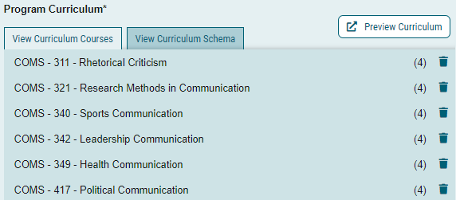

- Use the Add Course button if you are adding a course that is brand new (or coming soon) and not yet available using the Import feature. Please remember to add the credits for any course added manually.
- Under View Curriculum Schema, you will see the program breakdown by General Education (if applicable), Major Core, Electives, etc. Instead of Add & Import Courses, you can Add a Core. Adding a Core just creates a New Core that you can rename as needed. (Don’t choose to Import a Core at this time; Frankly, I don’t know how that works but I will find out.)
- Once you’ve clicked on a Core, you will now see Add Courses and Add Custom Text.
- Custom text is used for asterisks, “or,” “and,” and various notes that need to accompany a course entry in the table. It can be set to display before, after, left, or right of a particular course.
- When you click Add Courses on this page, it will bring up the list of course options from that first-page where you might have just imported additional courses (or manually added courses).
- By default, any courses you just add will appear at the bottom of that Core.

- You can click on a course and move it up or down as needed within that Core (you’ll get a 4-way cursor).

Those are the basic details on how to get started with the new Special-With Import version of the Program Creation form. Just complete the rest of the form, Save All Changes, and Validate and Launch Proposal.

I see this new form as perfect for the example above: creating a new concentration for an existing major where most of the major courses are the same. However, for those cases where a concentration can be attached to several majors (like those in Business), it’s simpler to use the traditional form.

Other uses would be for a variation on a major or minor that also retains most of the same courses: History Major used as a starting point for a Military History Major, for example. The main benefit is the ability to import courses that are already in the catalog instead of typing them in manually. This could also be used for some new Fast-Track programs—assuming the “template” you want to use already has a table presence in the catalog.

See the next page for a recap of when to use the new form.
TO RECAP

What kinds of Program Creations should use the Traditional Form?

- New Degree: AA, BSEE, MSIS, MFA, DM, etc.
- New Major: BA in Humanities, BS in Artificial Intelligence, MA in English
- New Minor that is not a variation on an existing minor: Astrophysics, Engineering
- New Concentration that can be attached to multiple majors.
- New Certificate: Certificate in Home Renovation, etc.
- New Accelerated/Fast-Track Combo, especially if there is no table presence in the current catalog.
- New Joint Degree at the Graduate Level (at this time, no Joint Degrees have a table presence in the catalog, so the import feature would not help).
- Any new program for which you would prefer to attach a file with the program table instead of using the curriculum feature. (See note below)

What kinds of Program Creations should use the Special-With Import Form?

- New Major within an existing Degree that will share lots of the same courses.
- New Minor that is a variation on an existing minor that will use lots of existing courses.
- New Concentration that is tied to only one major, and thus will share most of the major core.
- New Major within an existing Certificate type that will share some of the same courses.
- New Accelerated/Fast-Track Combo that is similar to another already in existence. An existing catalog table presence would also be helpful.

There may be other examples, but that’s all I can think of right now.

If you’re not sure if the Special-With Import proposal is the right form for your situation, just ask me.

NOTE: Special note about attaching a file versus using the curriculum feature. When possible, it is helpful for users to enter the courses in the curriculum portion of the proposal. That will help us push the info into the online catalog with less manual data entry. However, we know that it might be difficult in some cases, so a file attachment is always acceptable, especially for new programs.

Updated 9/11/23
Jane Leask

